**TUGAS PRAKTIKUM KONSEP PEMPROGRAMAN**

**JILID 12 part 1**



**Oleh :**

**Nama : Rosi Arif Mulyadi**

**NRP : 3121522021**

**Prodi : D3 Teknik Informatika PENS PSDKU Sumenep**

**Kelas : 1 ITA D3 Sumenep**

**Dosen :**

**Lusiana Agustien M.Kom**

**POLITEKNIK ELEKTRONIKA NEGERI SURABAYA**

**Praktikum 8 (1/4)**

**POINTER**

**Untuk setiap program di bawah ini,**

* + **gambarkan ilustrasi alokasi memori dari setiap baris pernyataan yang diproses**
  + **perkirakan hasil eksekusinya**

1. main(){

int y, x = 87;

int *px;

px = &x;

y = *px;

printf("Alamat x = %p\n", &x);

printf("Isi px = %p\n", px);

printf("Isi x = %d\n", x);

printf("Nilai yang ditunjuk oleh px = %d\n", *px);

printf("Nilai y = %d\n", y);

}

Jawab :

Gambar :

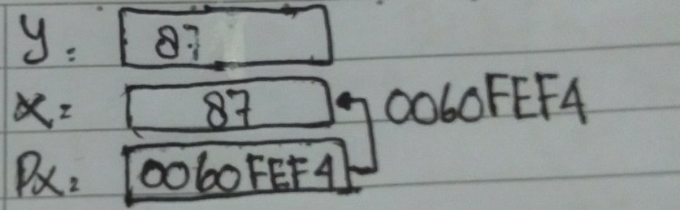

Perkiraan Jawaban :

Alamat x = 0060FEF4

Isi px = 0060FEF4

Isi x = 87

Nilai yang ditunjuk oleh px = 87

Nilai y = 87

Output :

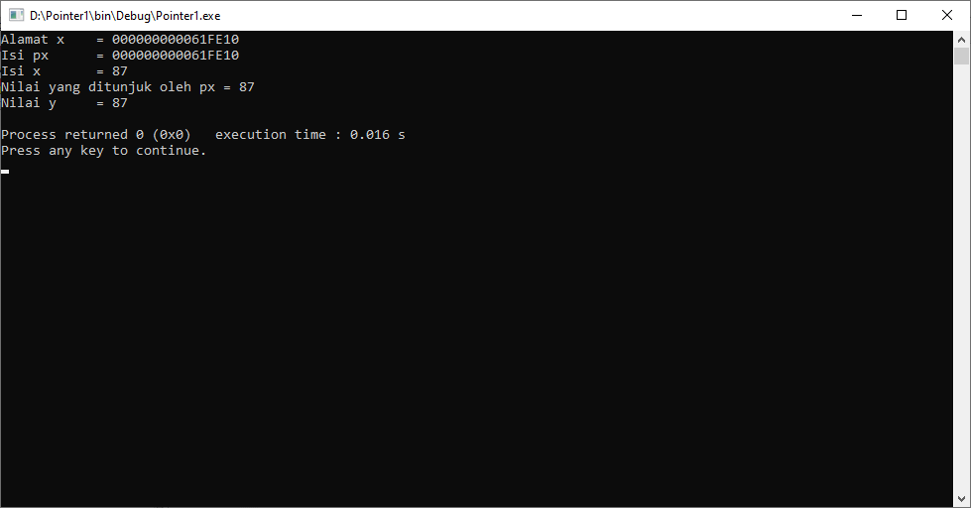

2. main(){

float *pu, nu;

double u = 1234.0;

pu = &u; nu = *pu;

printf("Alamat dari u = %p\n", &u); printf("Isi pu = %p\n", pu);

printf("Isi u = %lf\n", u);

printf("Nilai yang ditunjuk oleh pu = %f\n", *pu);

printf("Nilai nu = %f\n", nu);

}

Jawab :

Gambar :

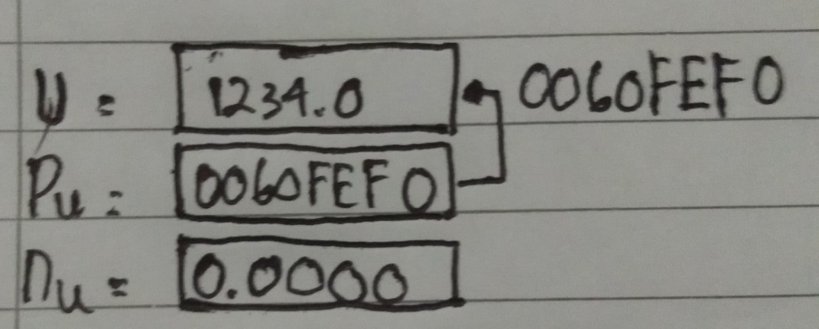

Perkiraan Jawaban :

Alamat dari u = 0060FEF0

Isi pu = 0060FEF0

Isi u = 1234.0

Nilai yang ditunjuk oleh pu = 0.000000

Nilai nu = 0.000000

Output :

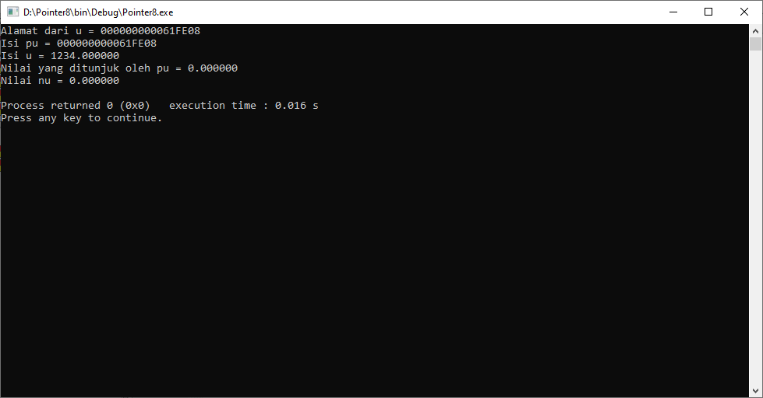

3. main(){

float d = 54.5f,*pd;

printf("Isi d mula-mula = %g\n", d);

pd = &d;

*pd += 10;

printf("Isi d sekarang = %g\n", d);

}

Jawab :

Gambar :

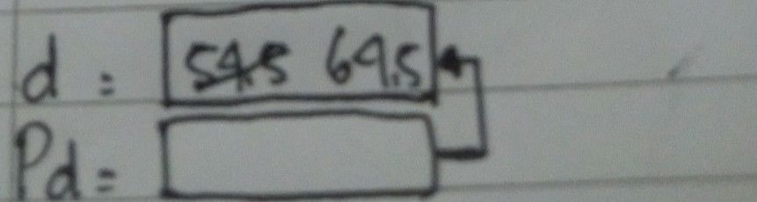

Perkiraan Jawaban :

Isi d mula-mula = 54.5

Isi d sekarang = 64.5

Output :

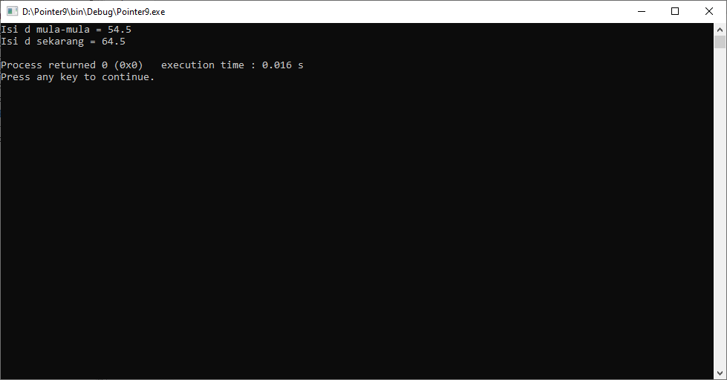

4. main(){

int z = 20, s = 30, *pz, *ps;

pz = &z;

ps = &s;

*pz += *ps;

printf("z = %d\n", z);

printf("s = %d\n", s);

}

Jawab :

Gambar :

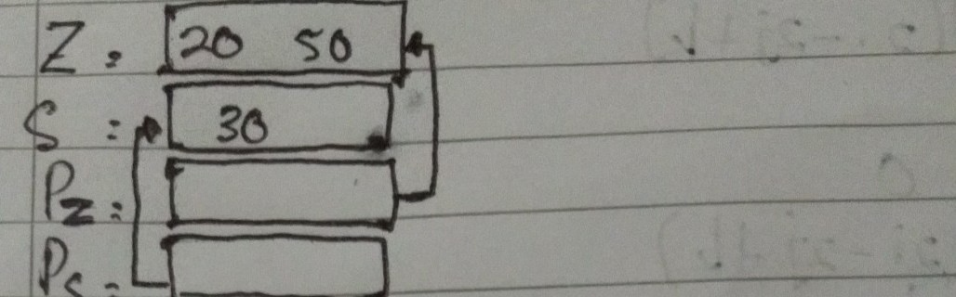

Perkiraan Jawaban :

z = 50

s = 30

Output :

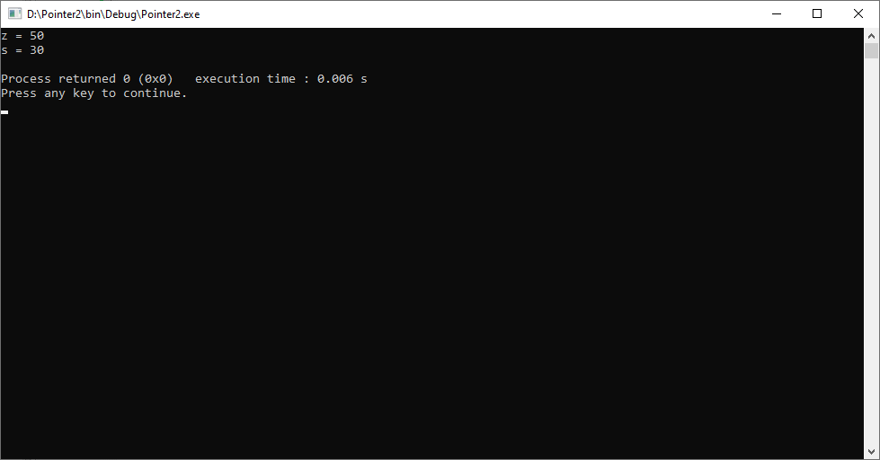

5. main(){

char c = 'Q';

char *cp = &c;

printf("%c %c\n", c, *cp);

c = '/';

printf("%c %c\n", c, *cp);

*cp = '(';

printf("%c %c\n", c, *cp);

}

Jawab :

Gambar :

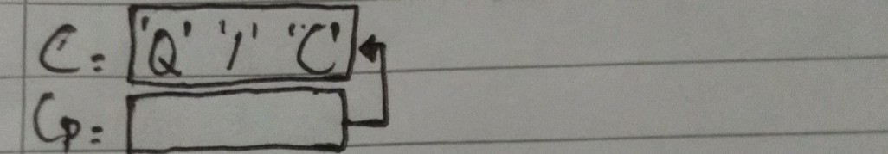

Perkiraan Jawaban :

Q Q

/ /

( (

Output :

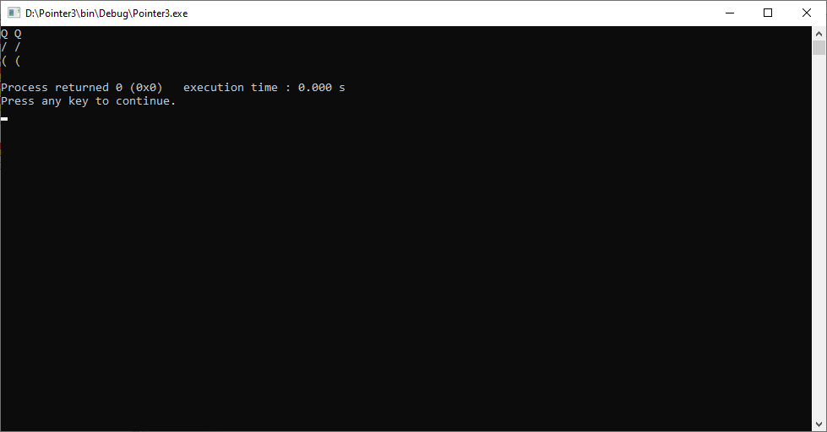

6. main() {

int x = 1, y = 2, *ip;

ip = &x;

y = *ip;

*ip = 3;

printf(“x = %d, y = %d”, x, y);

}

Jawab :

Gambar :

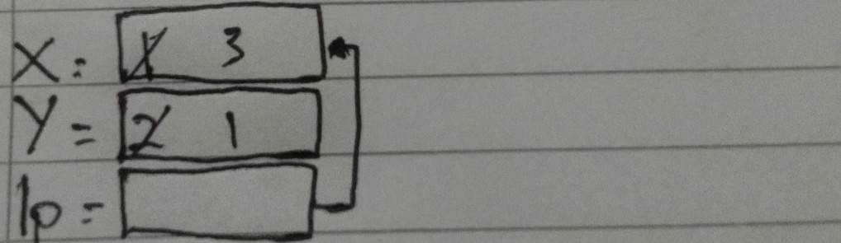

Perkiraan Jawaban :

x = 3, y = 1

Output :

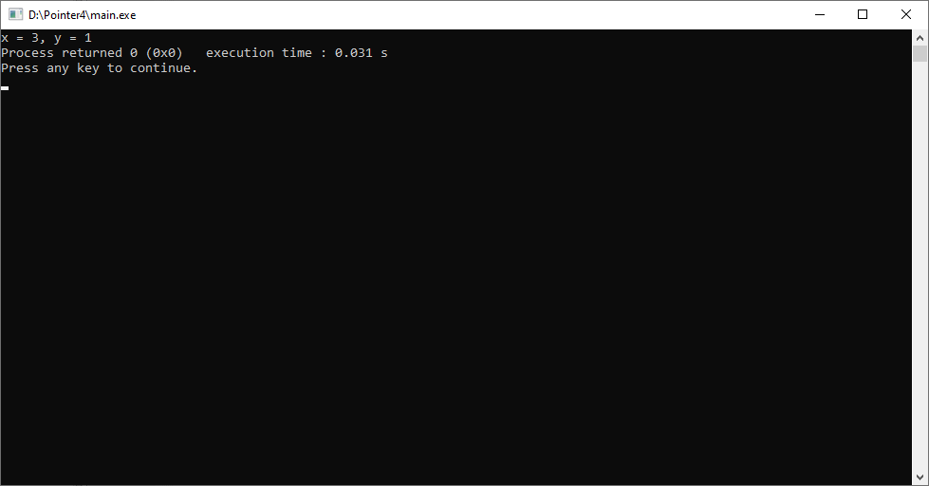

7. main(){

int i1, i2, *p1, *p2;

i1 = 9;

p1 = &i1;

i2 = *p1 / 2 – 2 * 3;

p2 = p1;

printf("i1=%d,i2=%d,*p1=%d,*p2=%d\n",i1,i2,*p1,*p2);

}

Jawab :

Gambar :

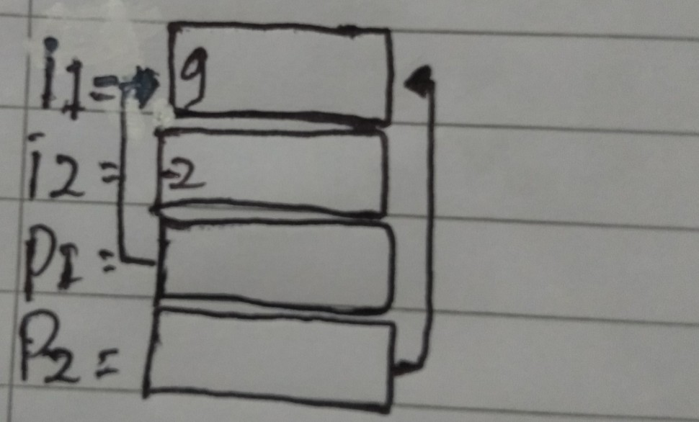

Perkiraan Jawaban :

i1=9,i2=-2,*p1=9,*p2=9

Output :

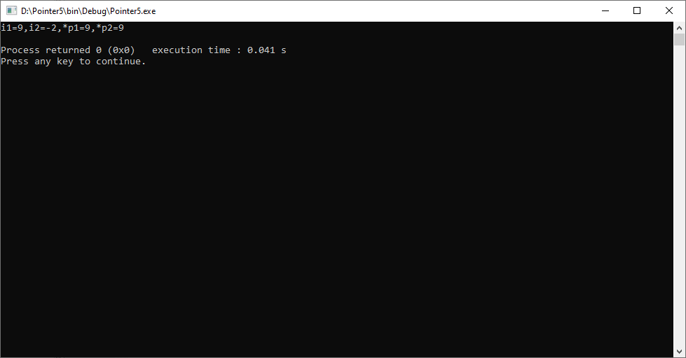

8. main() {

int count = 10, *temp, sum = 7;

temp = &count;

*temp = 32;

temp = &sum;

*temp = count;

sum = *temp * 4;

printf("count = %d, *temp = %d, sum = %d\n", count,*temp, sum );

}

Jawab :

Gambar :

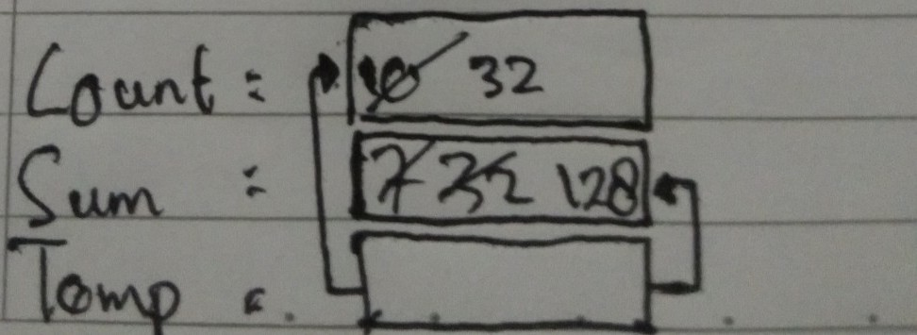

Perkiraan Jawaban :

count=32, *temp=128, sum=128

Output :

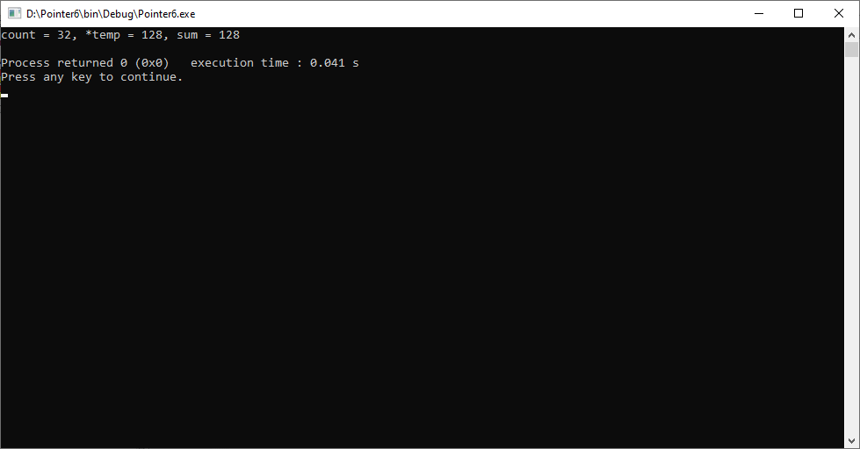

9. main(){

int count = 13, sum = 9, *x, *y;

x = &count;

*x = 27;

y = x;

x = &sum;

*x = count;

sum = *x / 2 * 3; printf("count = %d, sum = %d, *x = %d, *y = %d\n", count,sum,*x,*y);

}

Jawab :

Gambar :

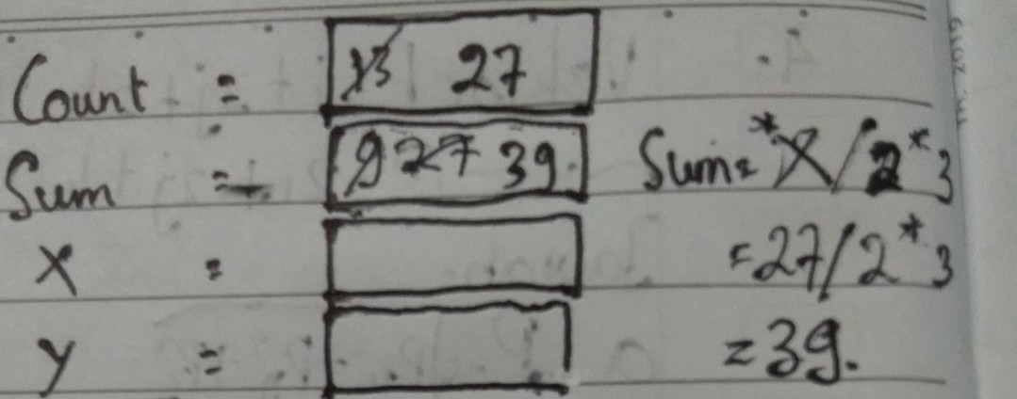

Perkiraan Jawaban :

count=27, sum=39, *x=39, *y=27

Output :

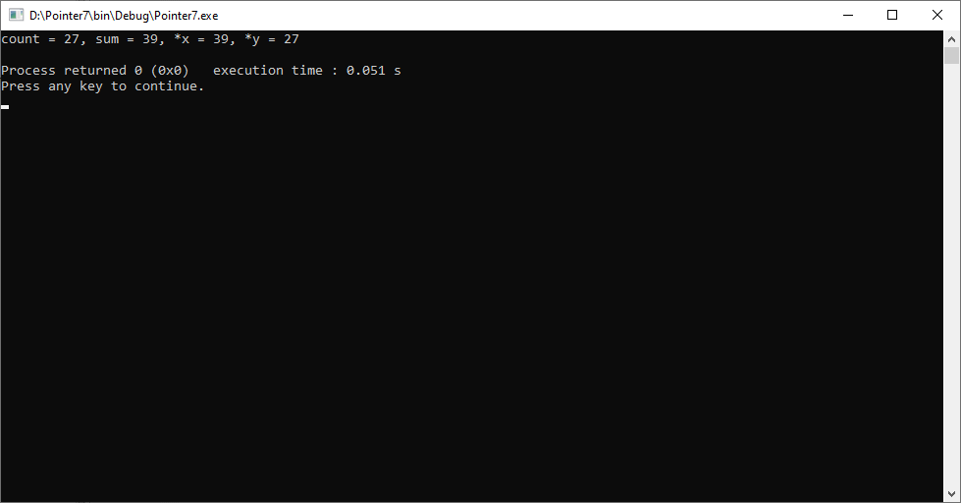

10. int r, q = 7;

int go_crazy(int *, int *);

main() {

int *ptr1 = &q;

int *ptr2 = &q;

r = go_crazy(ptr1, ptr2);

printf("q=%d, r=%d, *ptr1=%d, *ptr2=%d\n",q,r,*ptr1,*ptr2);

ptr2 = &r;

go_crazy(ptr2, ptr1);

printf("q=%d, r=%d, *ptr1=%d, *ptr2=%d\n",q,r,*ptr1,*ptr2);

}

int go_crazy(int *p1, int *p2){

int x = 5;

r = 12;

*p2 = *p1 * 2;

p1 = &x;

return *p1 * 3;

}

Jawab :

Gambar :

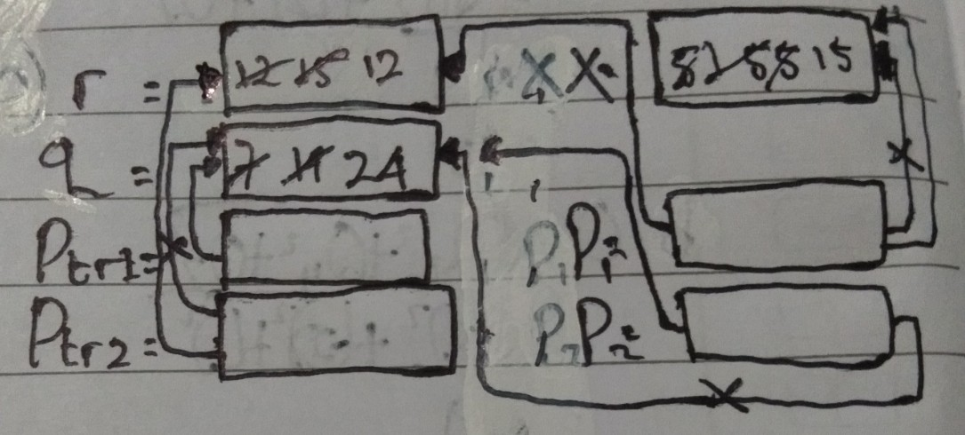

Perkiraan Jawaban :

q=14, r=15, *ptr1=14, *ptr2=14

q=24, r=12, *ptr1=24, *ptr2=12

Output :

